**Lab 9**

**Lab Conditions:**

This lab exercise to be completed by the end of the class. No late submission will be accepted.

Submit a word document or a PDF file in D2L @ Activities>> Assignments >> Lab 9

Make sure your following naming format as listed below:

Last name, First Name: ___Afonso, Markus_____ Student ID: _____A01333486______

**Part 1: Linux Basic Command Line**

Learning Objectives:

* How Linux files are organized and used
* Several important commands for examining and manipulating files.

Task Overview:

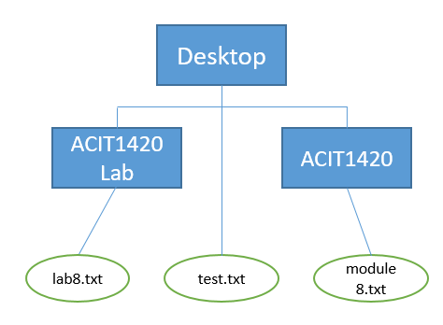

module9.txt

lab9.txt

username

Go to /home/user/mar28 and then create two subdirectories (“ACIT1420 Lab” and “ACIT1420”). Furthermore, cd into “ACIT1420 Lab” and create a text file called lab9.txt and then cd into ACIT1420 to create another txt file (module9.txt).

**Step 0:** Open your Linux VM (from last week optional task) Or your MacOS terminal.

If you don’t have any of the above two, you may use this simulator: Open URL (<https://bellard.org/jslinux/vm.html?cpu=riscv64&url=fedora33-riscv.cfg&mem=256>) in a browser, and then wait till it got loaded.

To check your current path

What does it say? (pwd) insert a screenshot here

|  |
| --- |
|  |

**Step 1:** Create a folder named as **mar28** (mkdir mar28), and then cd into it (cd mar28)

**Step 2:** Create two directories called “ACIT1420” and “ACIT1420 Lab”

**Step 3:** Create a file called test.txt (touch test.txt)

**Step 4:**  Run command “ls -l”, and insert a screenshot here

|  |
| --- |
|  |

**Step 5:** Change directory (cd) into “ACIT1420 Lab”, then create a file called **lab9.txt**

**Step 6**: Change directory (cd) into “ACIT1420”, then create a file called **module9.txt**

**Step 7**: Change directory (cd) to one level up (back to the folder of mar28)

**Step 8**: Run tree command (tree) and insert a screenshot here

|  |
| --- |
|  |

**Step 9:** Change the permissions of ACIT1420 (chmod) in Octal Mode as follows:

Owner: Read, Write, Execute;

Group: Execute;

Others: Execute;

**Step 10:** Change the permissions of ACIT1420 Lab (chmod) in Symbolic Mode as follows:

Owner: Read, Write, Execute;

Group: Read, Write;

Others: no permissions;

**Step 11:** Run command “ls -l”, and insert a screenshot here

|  |
| --- |
|  |

**Step 12:** Delete test.txt file

**Step 13:** Run tree command (tree) and insert a screenshot here

|  |
| --- |
|  |

**Part 2: Practice the Following Commands**

You don’t need to submit anything for this Part, just practice the following commands.

Some helpful Linux commands

**man**: Manual. Give this command with the command you need more information on, and a series of manual will appear that describe how to use the specified utility.

**cd**: Change Directory. Use cd to move to different directories on the network.

**cd ..** moves you up one directory in the tree.

**cd ~** or cd by itself will move you to your “home” directory.

**pwd**: Present Working Directory. Use pwd to see the name of the directory you are currently in.

**ls**: List. Use ls to see the contents of your current directory.

**ls –l**: List (Long option). Use ls –l to see file properties.

**ls –a**: List all files in the directory (including “hidden” files).

**rm**: Remove file(s).

**rm –r**: Remove a directory.

**mv**: Moves a file from one directory to another.

**cp**: Copy. Copies a specified file or files from a specific location to a specific location (directory). Source and destination files, with paths, must be specified.

**mkdir**: Make directory.

**rmdir**: Remove directory.

**more**: Display an ASCII text file on the screen.